LINQ and Control Break

Data file for button3 Data file for button4

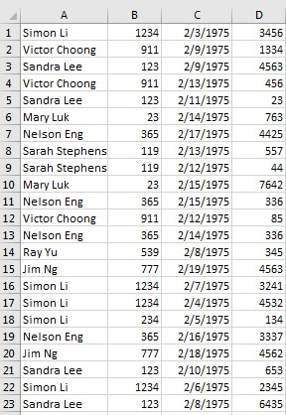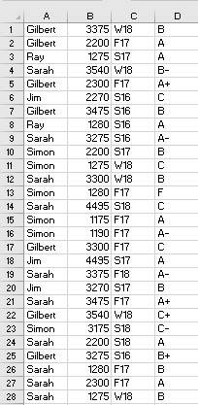

Result from button3

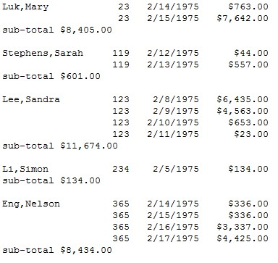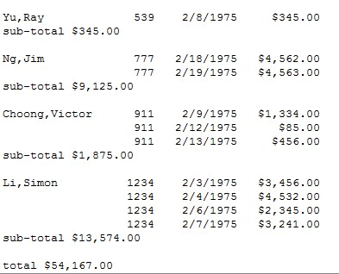

Program for button3

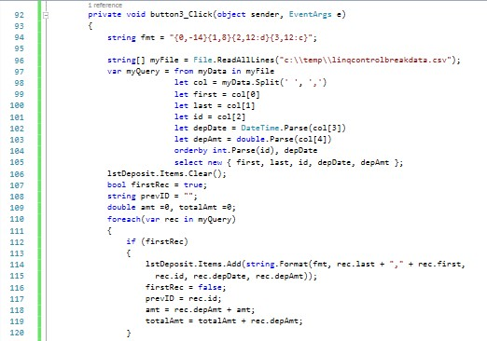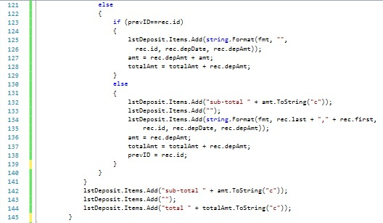

Output from button4

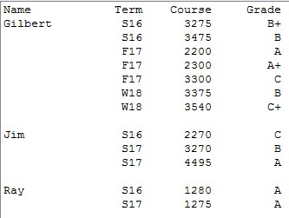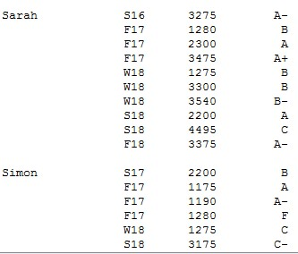

Program for button4

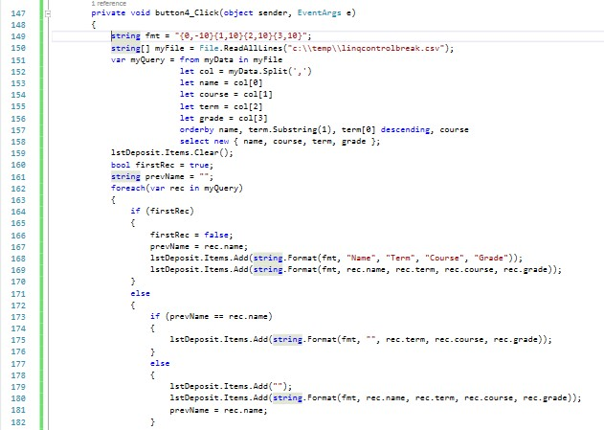

Logic for button number 4

Inside the foreach loop

Test if first rec

If so, show output, turn firsRec to False, set PreviousID with the current ID

If not first rec

Test Same ID (Previous ID == Current ID)

If so, show output without duplicates desired, (like name, or ID) do math as needed

If not, control break occurs, show blank, line, subtotal, reset subtotal, set Previous ID = Current ID, show output